You are an important part of your childs education!
Our names are Sandra and Maja and we work as parenting councellers at Annerstaskolan.
We have met with many parents whom we’ve helped with different things, for example questions about SL-kort or how to handle disobediance. If there is anything you are worried about as a parent or if you have questions concearning your child or your childs schooling we are happy to offer support. You as a parent decide if you want to meet with us and what you like to talk about.
It’s free of charge to schedule at meeting with us, we do not keep any personal data or notes. Our sessions are confidential wich meens we do not tell anybody who we meet.
To get in contact with us you can either tell your childs teacher that you like to be contacted by us, or you can contact us by phone of email. We can also book an interpreter if necessary.
We are looking forward to this fall and hope we will get to meet with you!
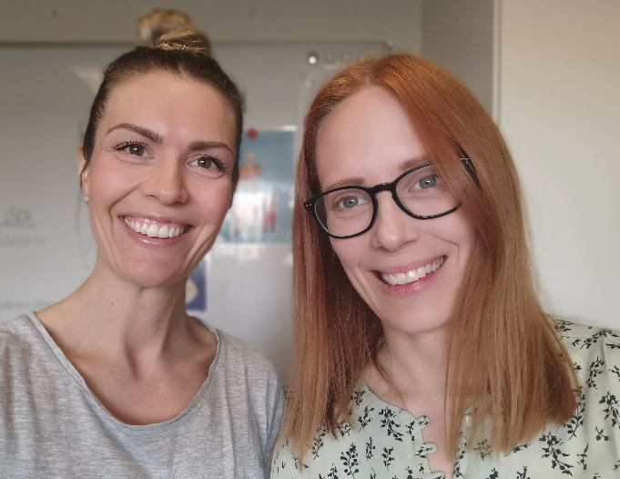
Maja Öberg 08-535 315 70 Sandra Edholm Ignat 08-535 315 71
Maja.Oberg@huddinge.se Sandra.Edholm-Ignat@huddinge.se

